No. | Answer
a 239.2 g
b 134.45 g
c 98.076 g
a n(BaSO₄) = 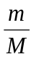 = 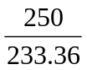 = 1.07 mol
b n(Fe₂O₃) = = 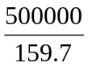 = 3.13 × 10³ mol
c n(C₆H₆) = = 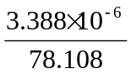 = 4.338 × 10^{–8} mol
d n(Al₂O₃) = = 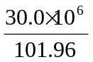 = 2.94 × 10⁵ mol
a N(electrons) = n × N_{A} = 1 × 6.022 × 10²³ = 6.02 × 10²³
b N(atoms) = n × N_{A} = 12.2 × 6.022 × 10²³ = 7.35 × 10²⁴
c N(atoms) = n × N_{A} = 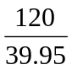 × 6.022 × 10²³ = 1.81 × 10²⁴
d N(molecules) = n × N_{A} = 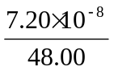 × 6.022 × 10²³ = 9.03 × 10¹⁴
a m(C₈H₁₈) = n × M = 40.0 × 114.224 = 4570 g
b m(C₁₄H₁₈N₂O₅) = n × M = 2.80 × 10^{–5} × 294.304 = 8.24 × 10^{–3} g
c m(Ca₃(AsO₄)₂) = n × M = 3.079 × 398.08 = 1226 g
a n(H) = 2.6 x 2 = 5.2 mol
b n(H) = 8.1 x 10⁻³ x 14 = 0.11 mol
c n(BeH₂) = = 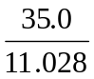 = 3.173 mol ∴ n(H) = 3.173 × 2 = 6.35 mol
d n(Al₂(HPO₄)₃) = = 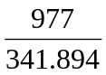 = 2.858 mol ∴ n(H) = 2.858 × 3 = 8.57 mol
M(XO₂) = 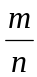 = 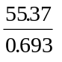 = 79.90 g mol^{–1}
∴ M(X + (2 × 16)) = 79.90 g mol^{–1}
∴ M(X) = 47.9 g mol^{–1}, and so element X is titanium.
a M(C₅H₅NO₂) = 111.1 g mol^{–1}
b m(C₅H₅NO₂) = n × M = 8.22 × 10^{–4} × 111.1 = 0.0913 g

